Name : - Sahaj Khurana
Roll No :- 224019
Course :- BSc. (Hons.) Computer Science

Lab Question :-
Create a Flutter app to show AppBar different parameters working.
Code :-
import 'package:flutter/material.dart';
void main() {
runApp(const MyApp());
}
class MyApp extends StatelessWidget {
const MyApp({Key? key}) : super(key: key);
@override
Widget build(BuildContext context) {
return MaterialApp(
home: Scaffold(
appBar: PreferredSize(
preferredSize: const Size.fromHeight(100.0),
child: MyAppBar(),
),
body: const Center(
child: Text('Your App Content Goes Here'),
),
),
);
}
}
class MyAppBar extends StatelessWidget {
@override
Widget build(BuildContext context) {
return AppBar(
toolbarHeight: 100.0,
backgroundColor: Colors.greenAccent,
title: const Text(
'My App',
style: TextStyle(color: Colors.white),
),
leading: PopupMenuButton<String>(
onSelected: (value) {
// Handle menu item selection
print(value);
},
itemBuilder: (BuildContext context) {
return {'Home', 'Contact Us', 'About'}.map((String choice) {
return PopupMenuItem<String>(
value: choice,
child: Text(choice)
);
}).toList();
},
),
actions: [
IconButton(
icon: const Icon(Icons.search),
onPressed: () {
// Add your search functionality here
},
),
IconButton(
icon: const Icon(Icons.camera),
onPressed: () {
// Add your camera functionality here
},
),
IconButton(
icon: const Icon(Icons.settings),
onPressed: () {
// Add your settings functionality here
},
),
],
);
}
}

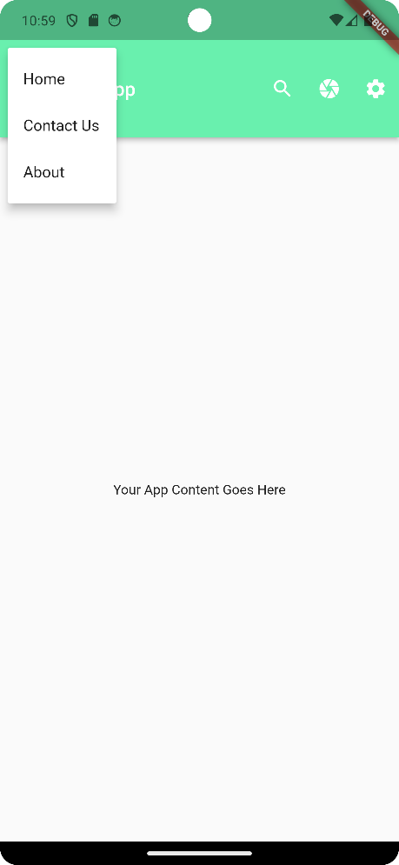
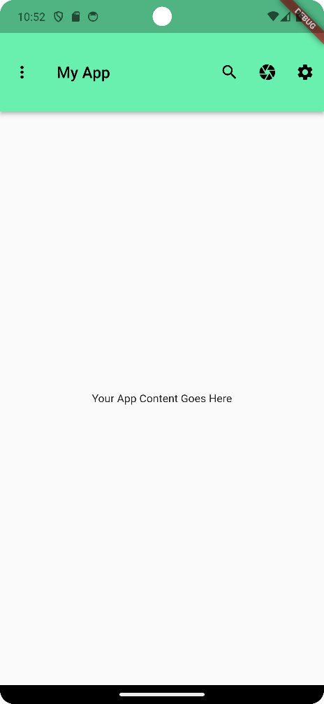
Output :-

